

MASENO 2025 KCSE PREDICTION
CONFIDENTIAL EXAM
121/1
MATHEMATICS
PAPER 1
TIME: 2½ HOURS

NAME……………………………………………………………………………………….
SCHOOL……………………………………………… SIGN…………………………..
INDEX NO……………………………………………. ADM NO………………………
Instructions to candidates
- Write your name, index number, school and stream in the spaces provided above.
- This paper contains two sections: Section I and Section II. Attempt all the questions in section I and strictly any five questions from Section II.
- All answers and working must be written on the question paper in the spaces provided below each question.
- Show all the steps in your calculations, giving your answers at each stage in the spaces below each question.
- Marks may be given for correct working even if the answer is wrong.
- Non-programmable silent electronic calculators and KNEC mathematical tables may be used, except where stated otherwise.
- Answer the questions in English

FOR OFFICIAL USE ONLY:
SECTION I
1 | 2 | 3 | 4 | 5 | 6 | 7 | 8 | 9 | 10 | 11 | 12 | 13 | 14 | 15 | 16 | Total

SECTION II
17 | 18 | 19 | 20 | 21 | 22 | 23 | 24 | Total

GRAND TOTAL

SECTION I: (50 MARKS)
Attempt all questions in the spaces provided
- An irregular 6 sided polygon has two of its interior angles equal to 2x each, three angles equal to x each and one side equal to 20º
Calculate the value of x (3marks)

- The diagonals of a parallelogram are 20cm and 28.8cm. The acute angle between the diagonals is 62º. Calculate the area of the parallelogram. (3marks)

- A mobile phone seller gets a commission of shs 250 on every mobile phone that he sells. In a given month he got 33,000 shillings.
- How many phones did he sell that month (1mark)

- If this commission is 2% what is the sale price of each mobile phone. (2marks)

- Given that Sin x=3/4, without using tables or calculators, find.
- Cos xº (2marks)

- Tan (90-x)º (1mark)

- Solve the simultaneous equation
2log y = log2 + log t
2^{y} =4^{t} (4marks)

- Evaluate without using tables or a calculator
100^{-1.5} x 32^{0.2} (3marks)

- The angle subtended by the major arc at the center of the circle O is twice the angle substended by the minor arc at the center. If the radius of the circle is 3.5cm. Find the length of the minor arc. (3marks)

- Two trains T₁ and T₂ travelling in the opposite directions on a parallel tracks are just beginning to pass one another. Train T₁ is 72m long and is travelling at 108km/hr. Train T₂ is 78m long and is travelling at 72km/hr. Find the time in seconds the two trains take to completely pass one another (3marks)

- The angle of depression of a chick from the hawk on top of a vertical tree 8m tall is 28º. On seeing the hawk, the chick moves directly towards the base of the tree to a point P such that the angle of elevation of the hawk from P is 32º. Calculate the distance moved by the chick. (4marks)

- Find a 2 x 2 matrix m such that (3marks)
1 3 4 -6 1 7
m +
=
2 -1 2 0 3 -2

- Given that a=1.2, b =0.02 and c =0.2 Express ac +b in the form ^{m}/_{n} where m and n are integers (3mark)

- The line passing through the point P(-1,3w) and Q(w,3) is parallel to another line whose equation is 2y -3x =9 .
Write down the co-ordinates of P and Q (3marks)

- A certain volume of solution has a mass of 2.2kg with density of 0.8g/cm³. Calculate the volume of the solution in liters (3marks)

- The graph below shows frequency densities for the masses of same 200 students selected from a class. Use it to answer the questions that follows.
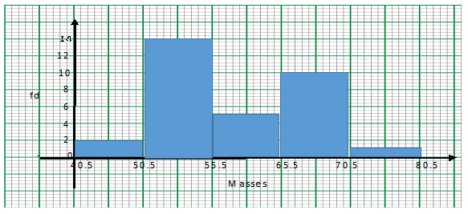

- Complete the frequency distribution table below. (2 marks)
Mass in kg
frequency
- State the modal frequency (1mark)

- Calculate the area bounded by the curve y=x², the line y= -1 and the lines x=0 and x=3 using trapezoidal rule with 7 ordinates (correct to 3 d p) (3marks)

- Mutai imports rice from United States at the initial cost of 500 US dollars per tonnes. He then pays 20% of this amount as shopping costs and 10% of the same amount as custom duty. When the rice reaches Mombasa he has to pay 6% of the initial cost to transport it to Nairobi. Given that on the day of this transaction the exchange rate was 1 us dollar =kshs 76.60. calculate the total cost of importing one tonne of rice up to Nairobi in Kenya shillings. (3mks)

SECTION II (50 MARKS)
Answer only 5 questions from this section.

- (a) On the Cartesian plane given below, draw the quadrilateral ABCD with vertices A( 6,6), B(2,2) C(4,-6) and D(8,0). (1mrk)
A¹¹
C¹¹
D¹¹
B¹¹

7
6
5
4
3
2
1

-1
-2
-3
-4
-5
-6

-6 -5 -4 -3 -2 -1 0 1 2 3 4 5 6 7 8 9

  - Draw the image A¹B¹C¹D¹ of ABCD under an enlargement scale factor ½, center origin. State the coordinates of A¹B¹C¹D¹ (3mrks)

  - Describe the transformation that maps A¹B¹C¹D¹ onto the given image A¹¹B¹¹C¹¹D¹¹ (2mark)

  - Rotate A¹¹B¹¹C¹¹D¹¹ about center (-2,-1) through a positive quarter turn to get A¹¹¹B¹¹¹C¹¹¹ D¹¹¹. State the co-ordinates of A¹¹¹B¹¹¹C¹¹¹D¹¹¹ (3marks)

  - State a pair of quadrilaterals that are oppositely congruent. (1mark )

- On a certain day, Mwema bought plates worth Kshs 1200. On another day, Mrs. Mwema spent the same amount of money but bought the plates at a discount of 20% per plate.
  - If Mwema bought a plate at Kshs x, write down a simplified expression for the total number of plates bought by the two people (3marks)

  - If Mrs. Mwema bought 6 plates more that her husband, find how much each spent on a plate. (5marks)

  - Find the total number of plates bought by the family (2marks)

- (a) Using a ruler and a pair of compasses only, construct triangle ABC such that lines AB=5.5cm, BC=4.8cm and AC =6.8cm, Construct circle passing through vertices A, B and C (6 marks)

  - Measure the radius of the circle (1mark)

  - Measure the angle substended at the center of the circle by chord AC (1mark)

  - Hence calculate the area of the triangle AOC (2marks)

- A particle P moves in a straight line such that t seconds after passing a fixed point Q , its velocity is given by the equation 2t² -10t +12
Find
- The values of t when P is instantaneously at rest. (2marks)

- An expression for the distance moved by P after t seconds. (2marks)

- The total distance travelled by P in the first 3 seconds after passing point Q (2marks)

- The distance of P from Q when acceleration is zero. (4marks)

- The figure below shows a model of a pillar to be constructed at the Canterbury. The model consists of a circular base of diameter 21cm and a uniform hexagon stand of sides 6cm and height 20cm.
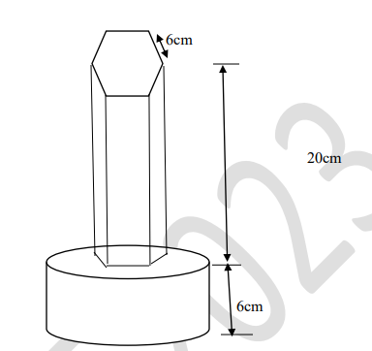
20 cm
- Calculate the cross-sectional area of the hexagon to 2dp. (3marks)

- Calculate the total volume of the model to 2dp. (3marks)

- If the height of the red pillar is 52m and the constructor uses two bags of cement for every 500m³ of the construction. Calculate the least number of bags of cement required (4marks)

- The diagram below shows a triangle OPQ in which QN: NP=1:2, OT: TN=3:2 and M is the mid-point of OQ.
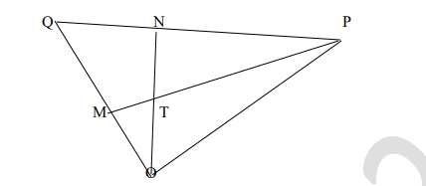
- Given that OP=P and OQ =q. Express the following vectors inters of p and q
- PQ (1mark)

- ON (2marks)

- PT (2marks)

- PM (1mark)

- (i) Show that points P,T and M are collinear (3marks)

(ii) Determine the ratio MT ; TP (1mark)

- The diagram below shows a triangle ABC Circumscribed in a circle with AB=12cm BC=12cm, BC=15cm and AC=14cm
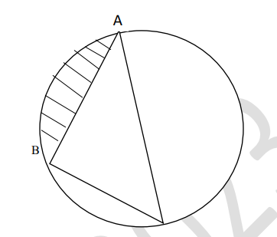
Calculate to 4 significant figures
- The angle ACB (3marks)

- The radius of the circle (3marks)

- The area of the shaded region (4marks)

- If Nick gives a quarter of the money he owns to Tom, Tom will have twice as much as Nick. If Tom gives q shillings to Nick, then Nick will have thrice as much as Tom. Taking the initial amount owned by Nick and Tom to be x and y respectively;
- Express y and q in terms of x (7marks)

- Given that Nick’s initial amount was Kshs 40,000. calculate the value of q (1mark)

- The initial amount owned by Tom (2marks)

THIS IS THE LAST PRINTED PAGE

